**Atleto**

**Name: Vinitha Koppula**

**NU ID: 001374627**

Atleto is an application for facilitating fitness class registrations held in various gyms. It will have three user roles, Admin, Host, and Customer. Each role will have to register himself before logging in. Admin will be able to add new gyms in the site after logging in. Host after logging in, can be able to add and update classes that are going to be held in their gym. Customer after logging in, will be able to see all the classes posted by various hosts with details. Customer can join any class and if prompted to join the same class again, application will not allow. Customer can view all the classes he has joined and can also search for a particular class based on gym name or class name. Filters have been implemented to filter out script and sql injection characters.

**Roles:** Admin, Customer and Host.

**Admin:** Admin can register and log in. Add gyms to the site.

**Host:** Host can register and login. Can add and update classes of their respective gym only.

**Customer:** Customer can register and login, search for a class, join and can view joined classes.

**Technologies Used:** Spring MVC, Hibernate, Validator, Filters.

**Functionality:** Unauthorized access to the application and few pages is been prohibited, Validator and Filters have been implemented.

**Home Page:**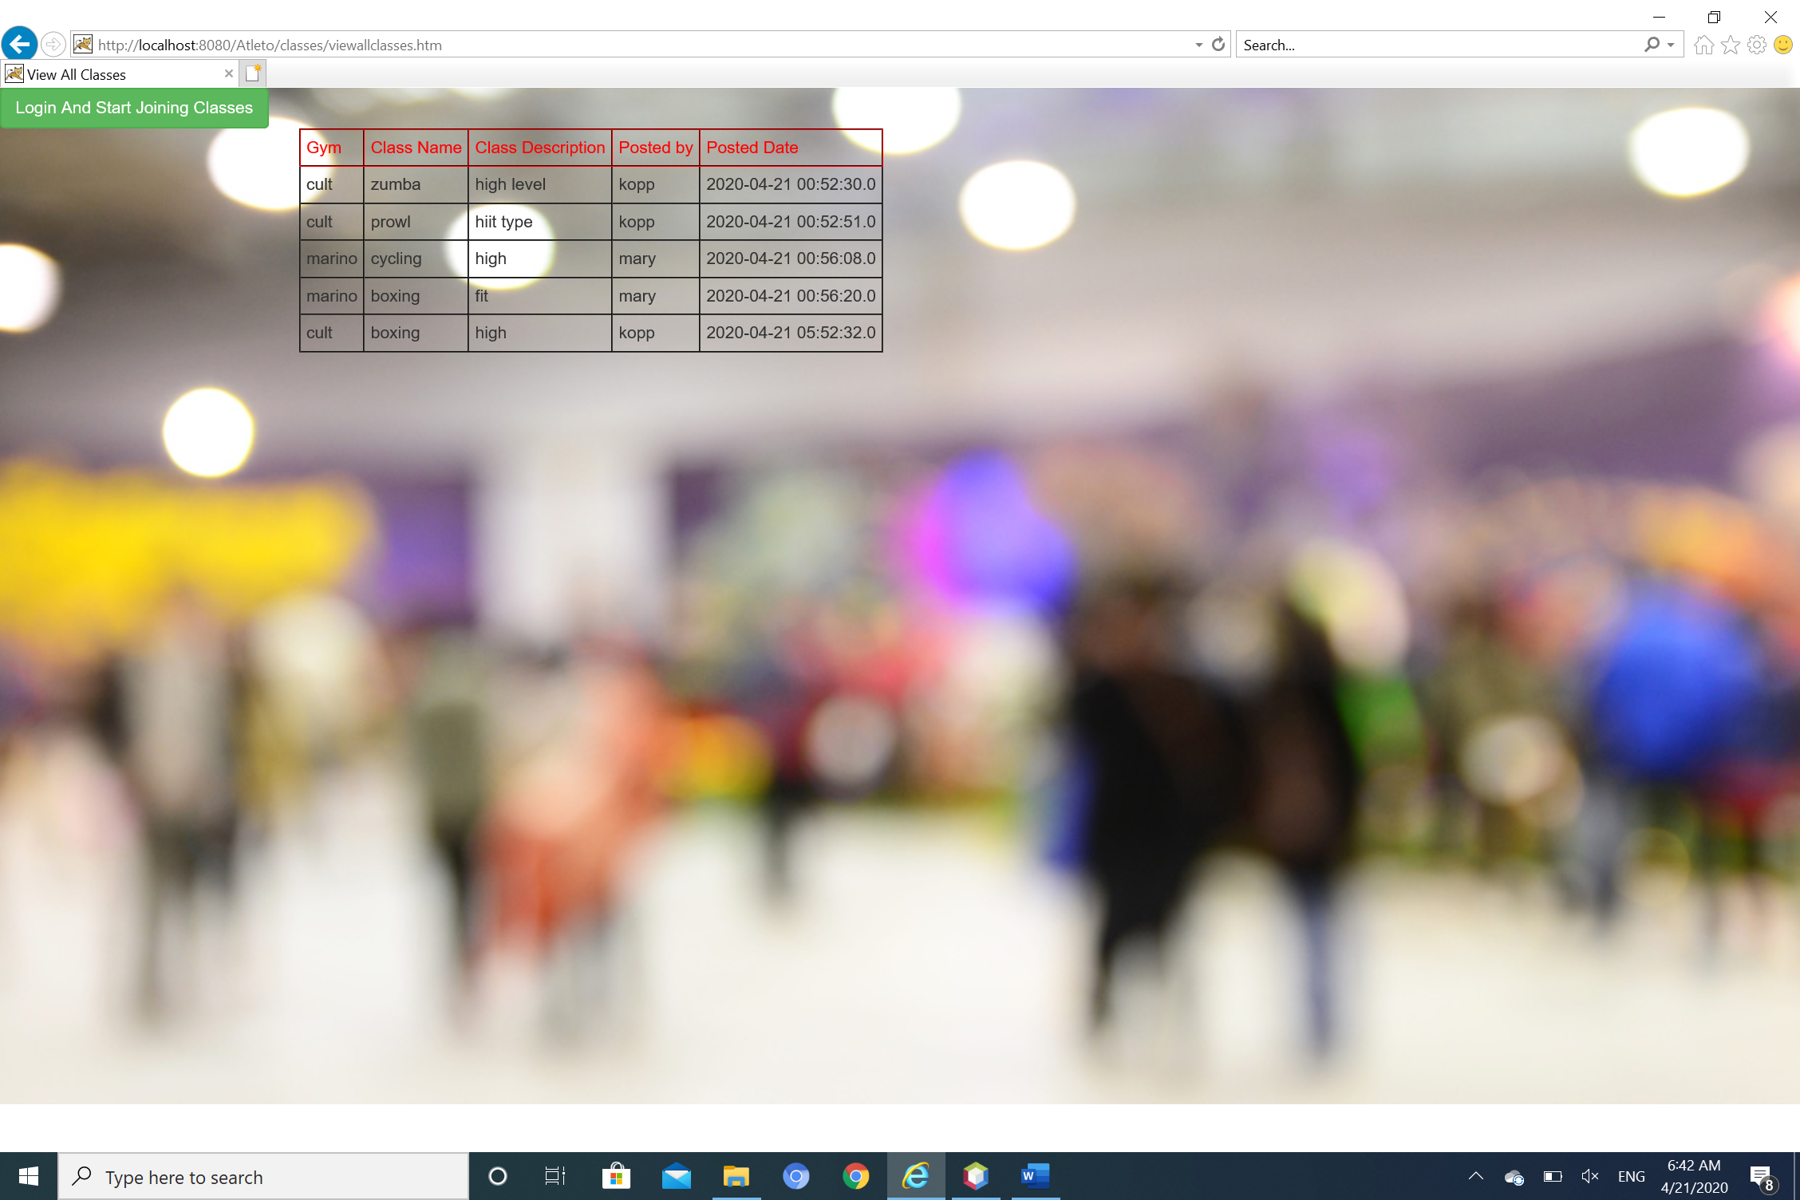

**Login Page:**

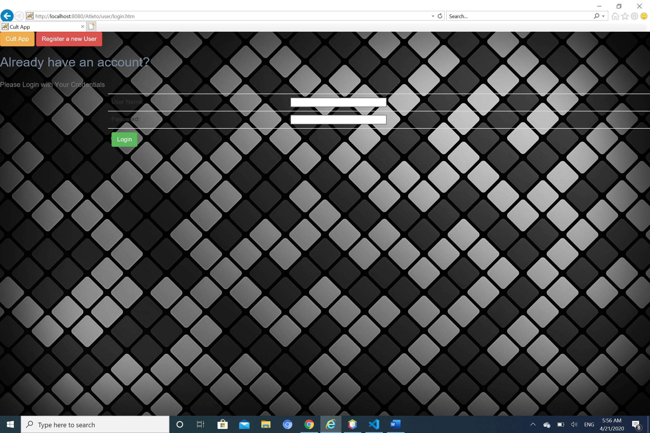

**Registration Page:**

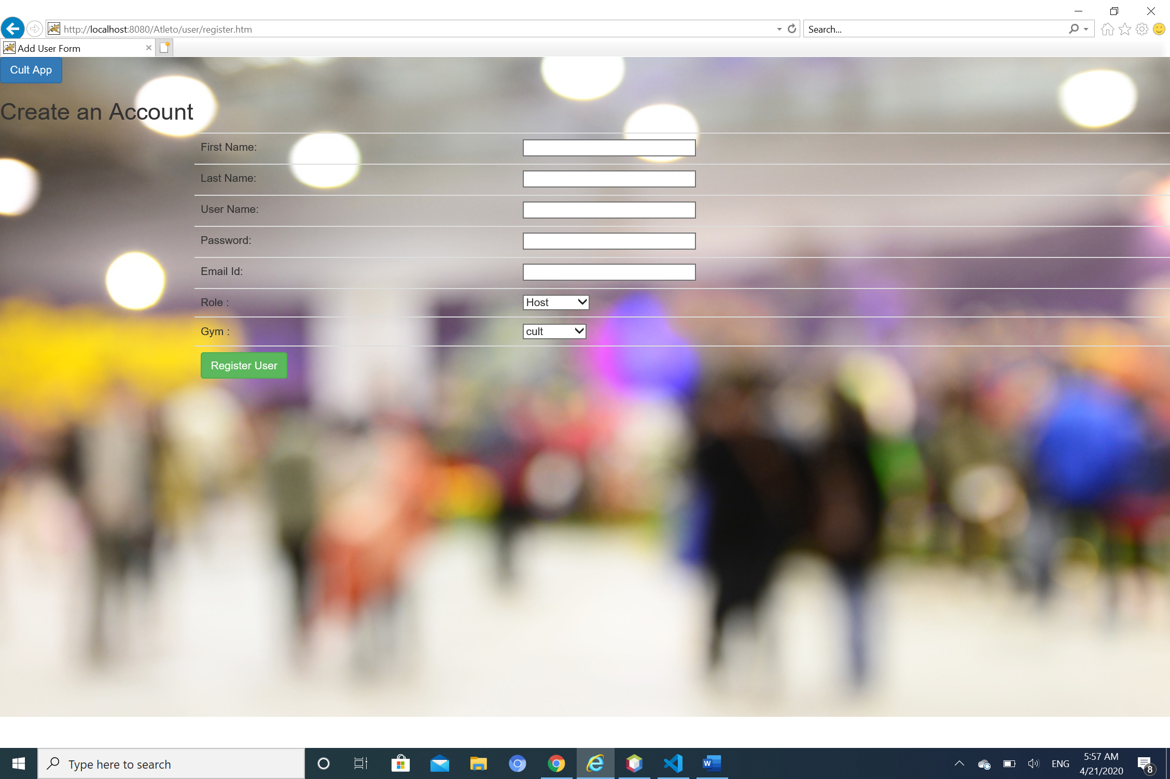

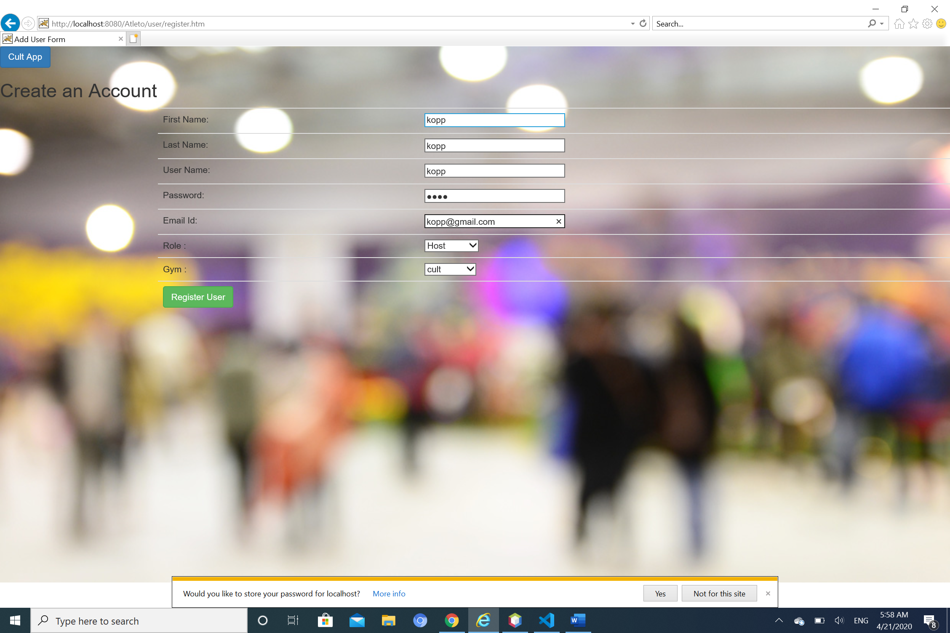

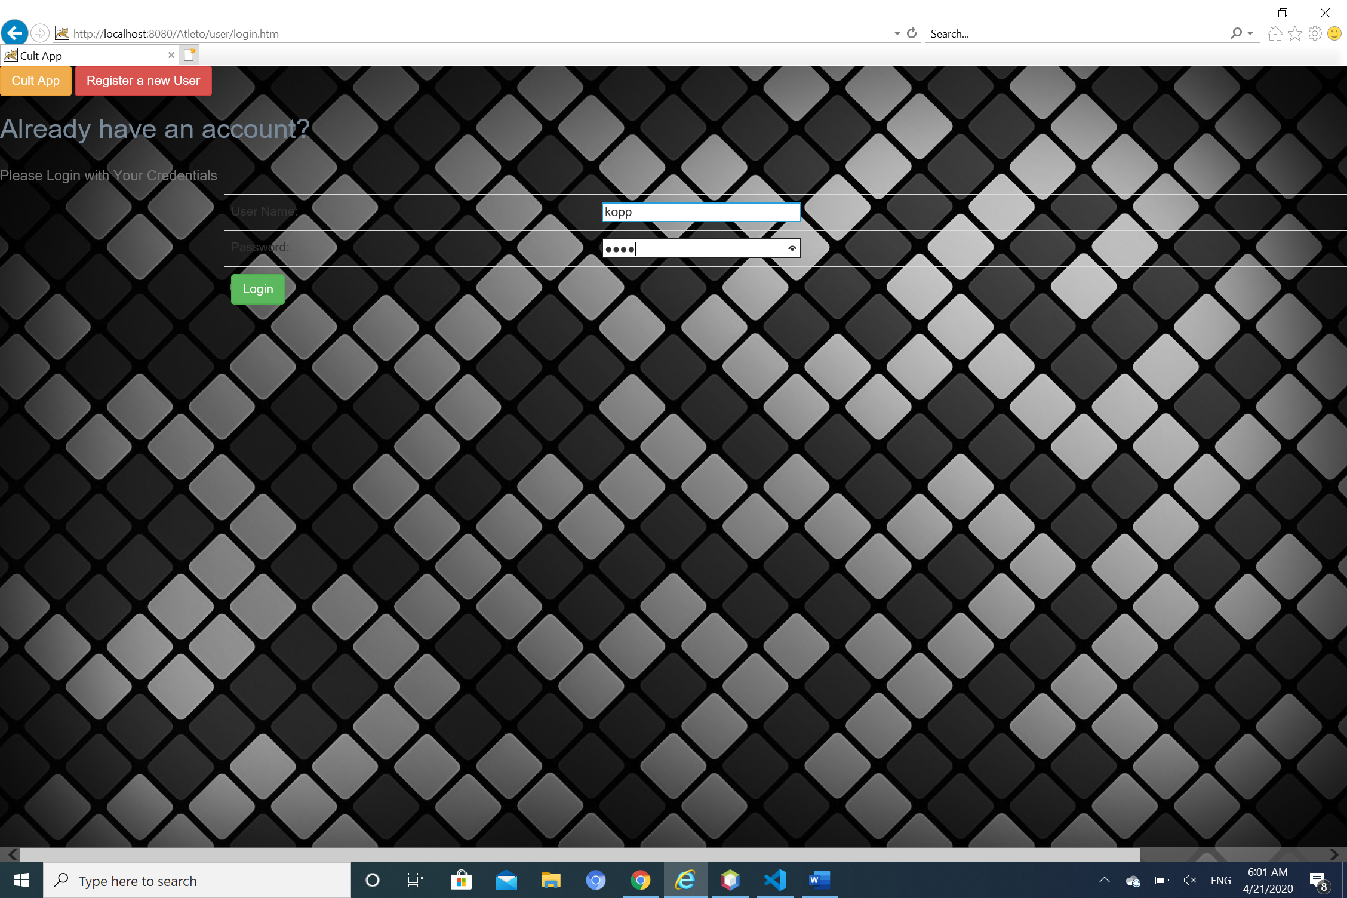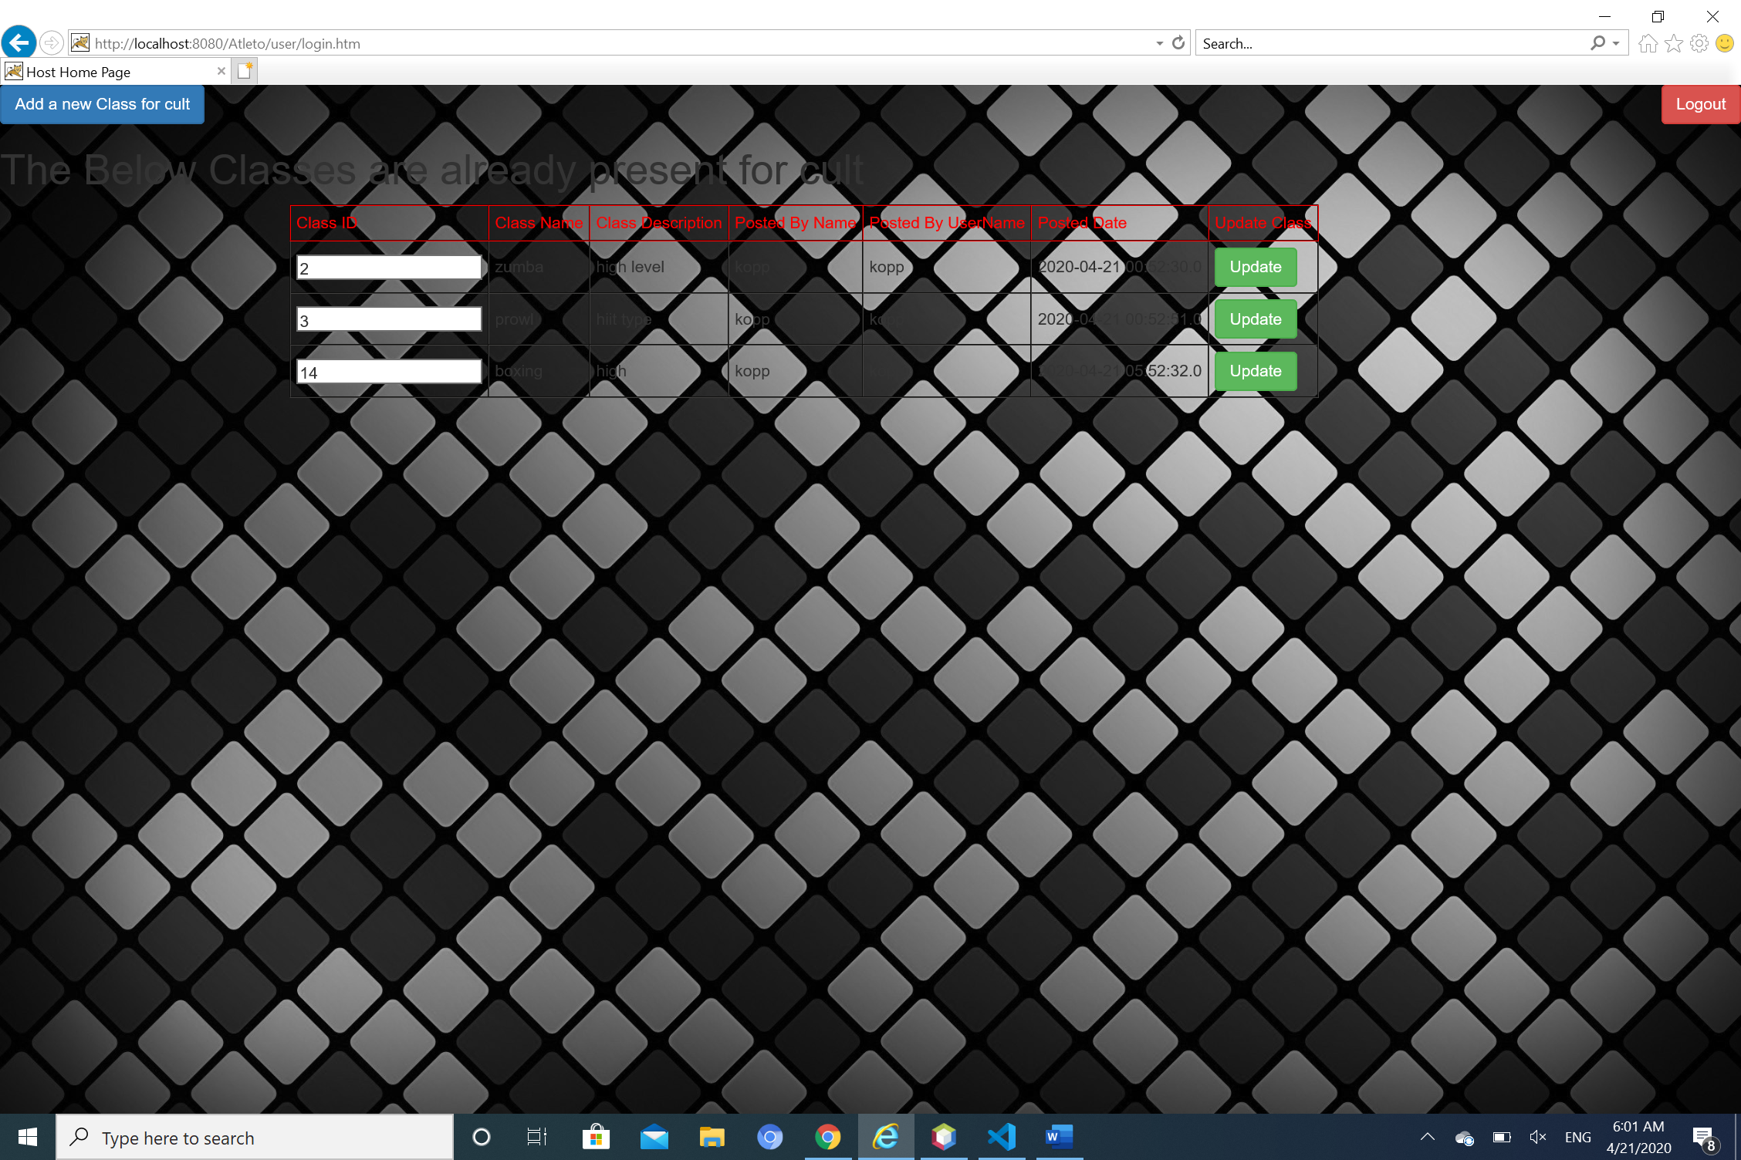

**Customer registration:**

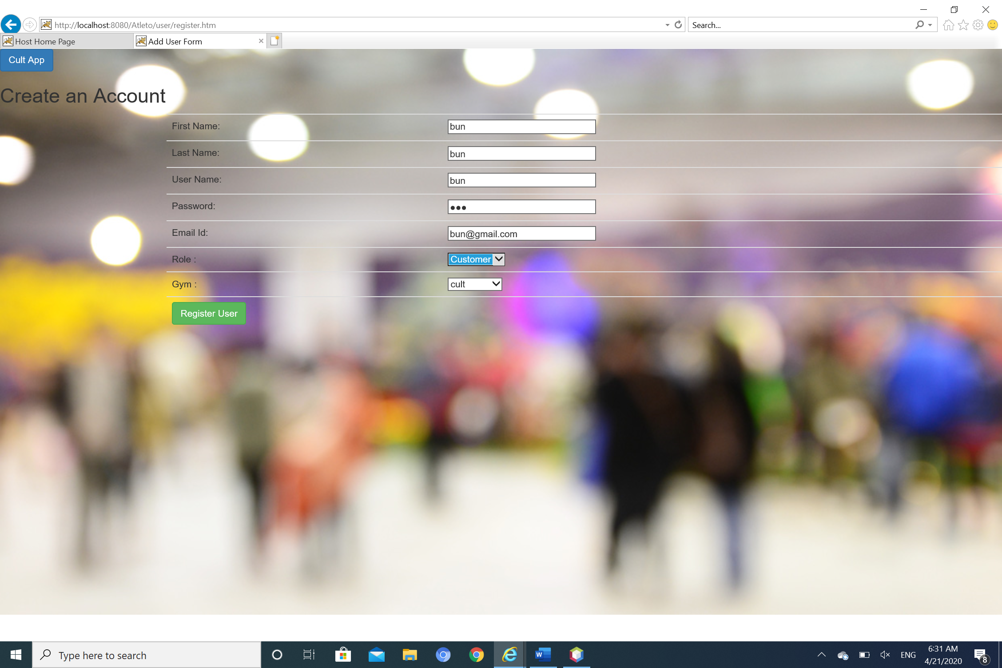

**If username already exists,**

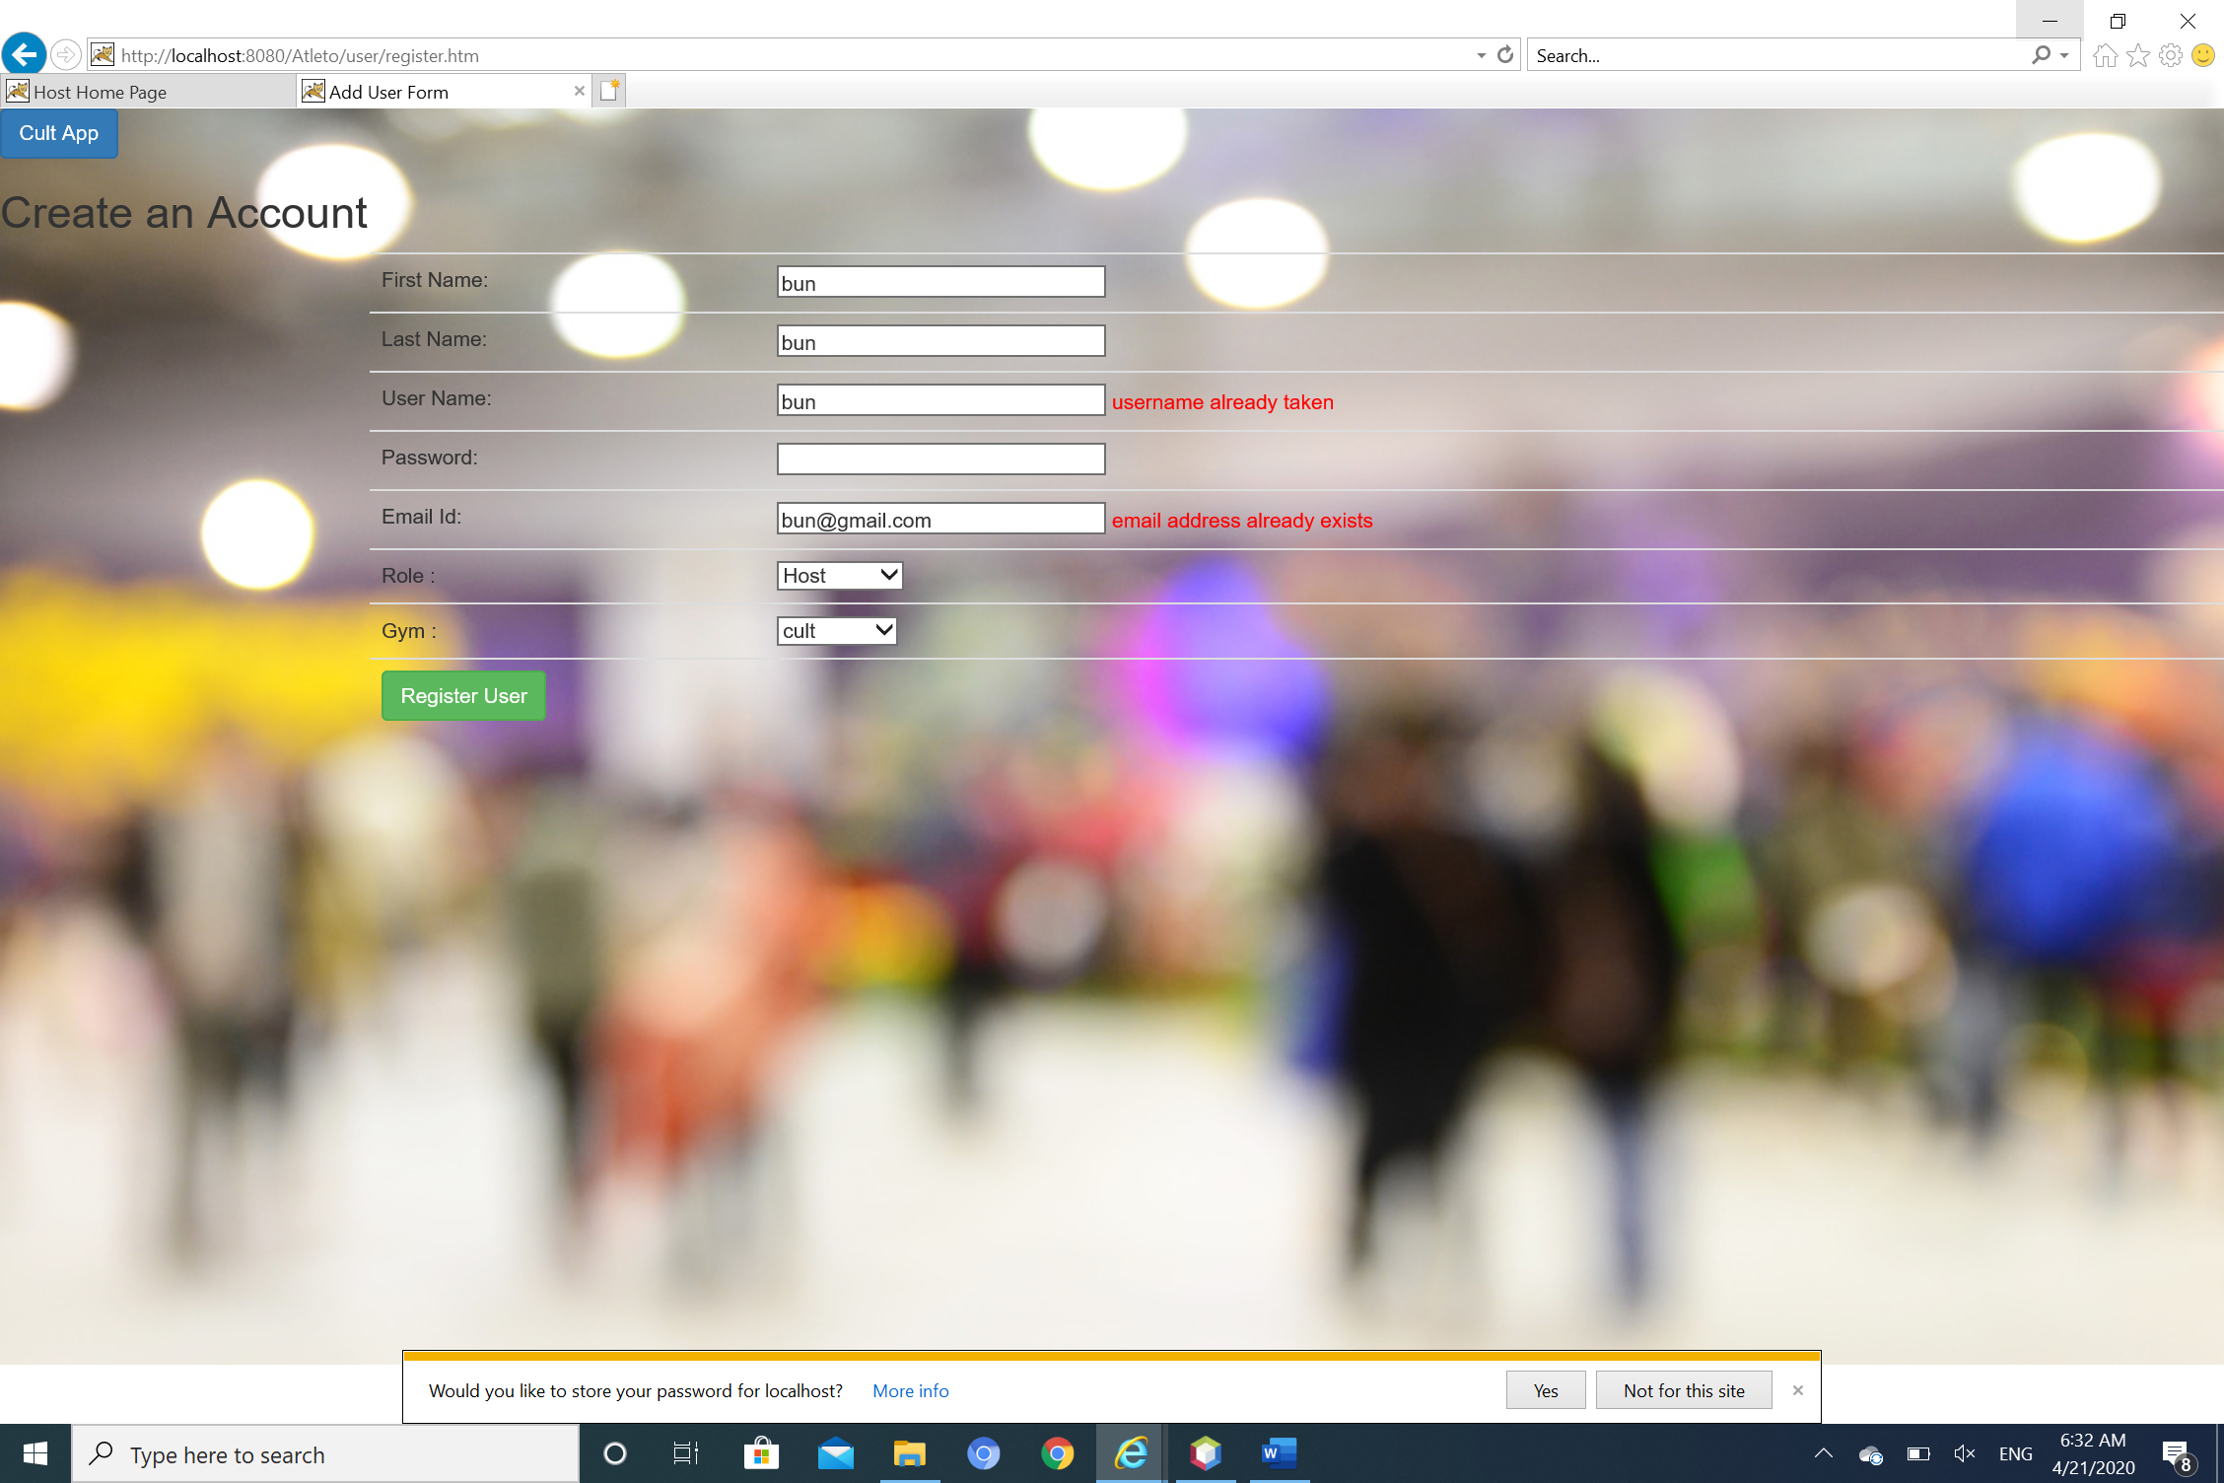

**Customer login:**

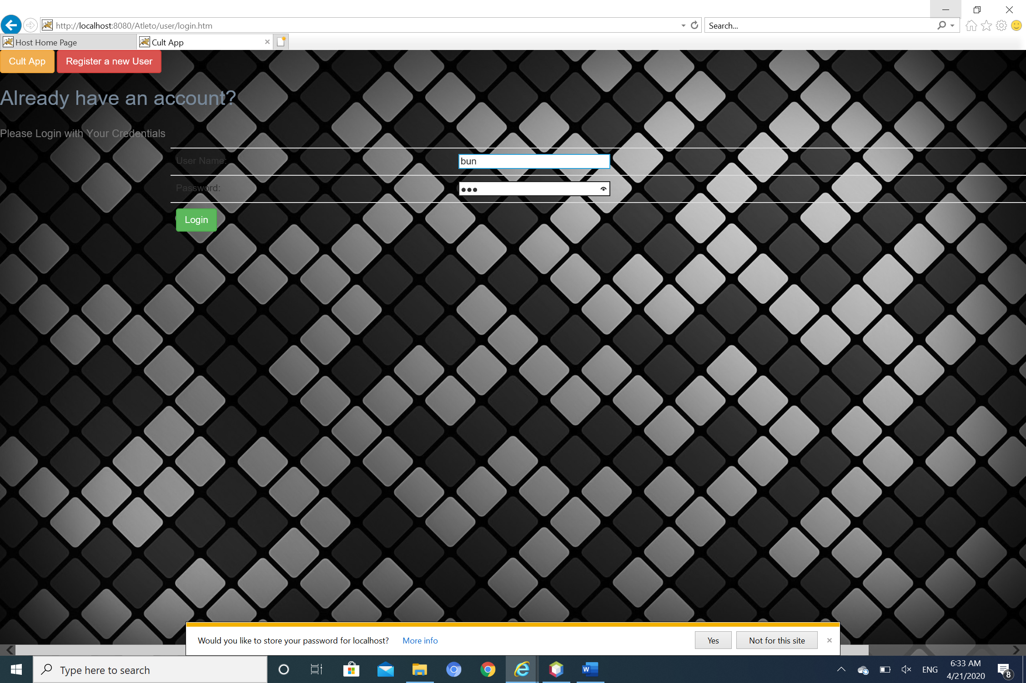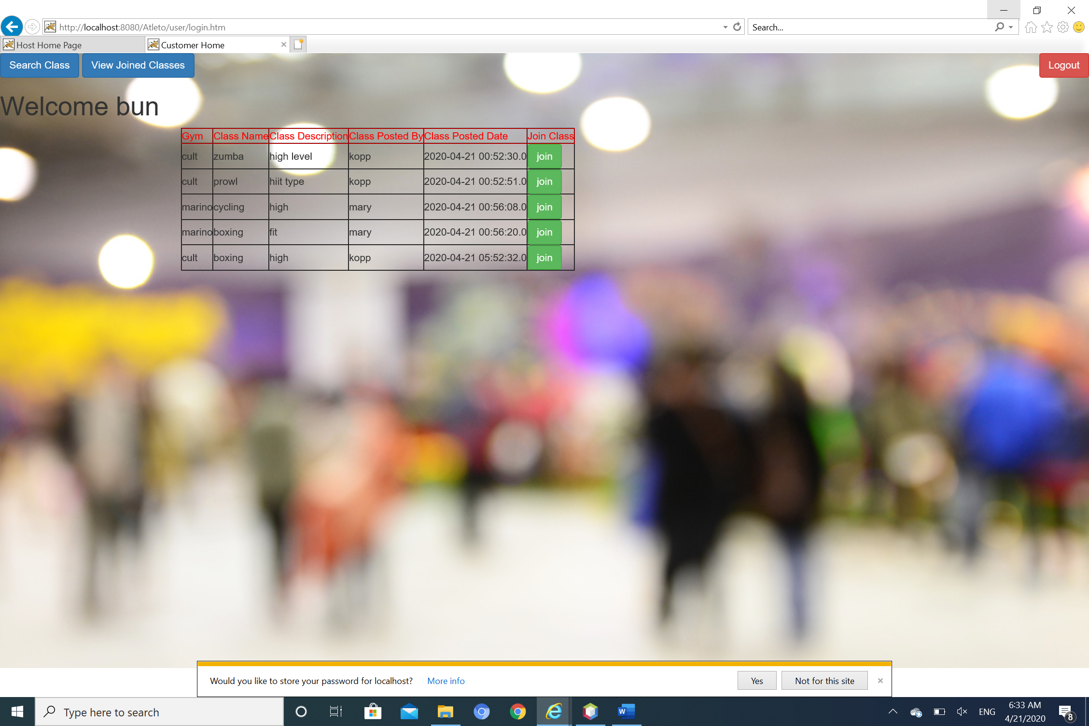

**Search screen:**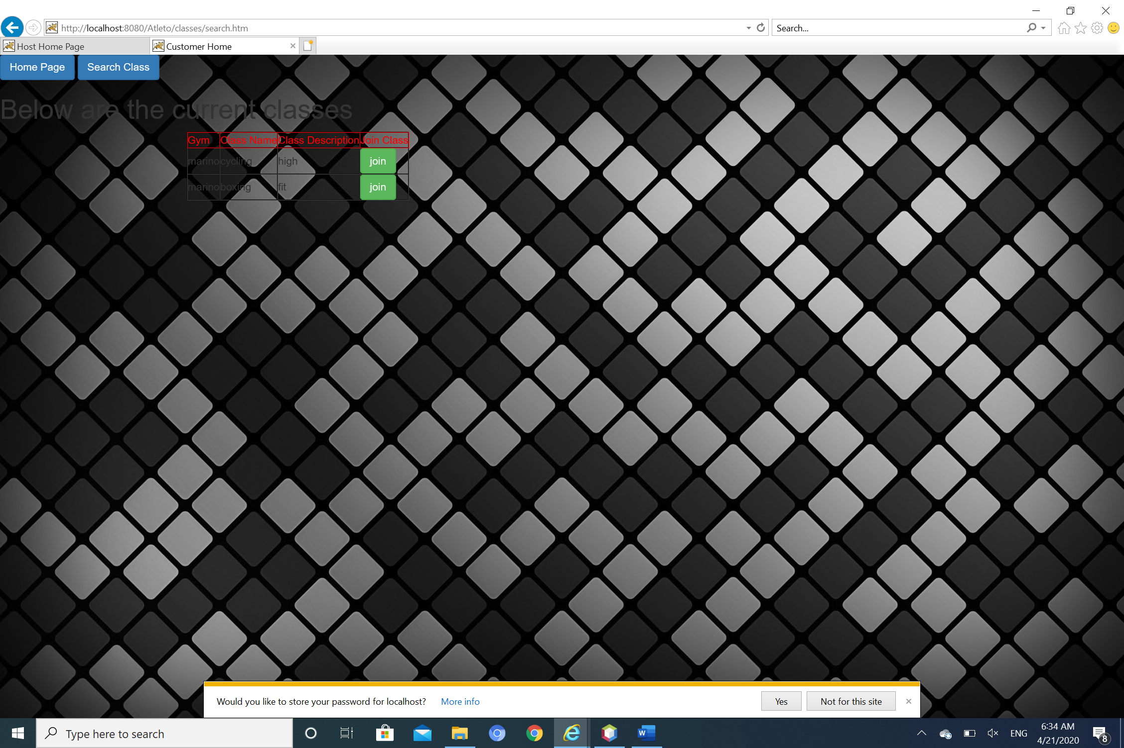

**Joined Classes:**

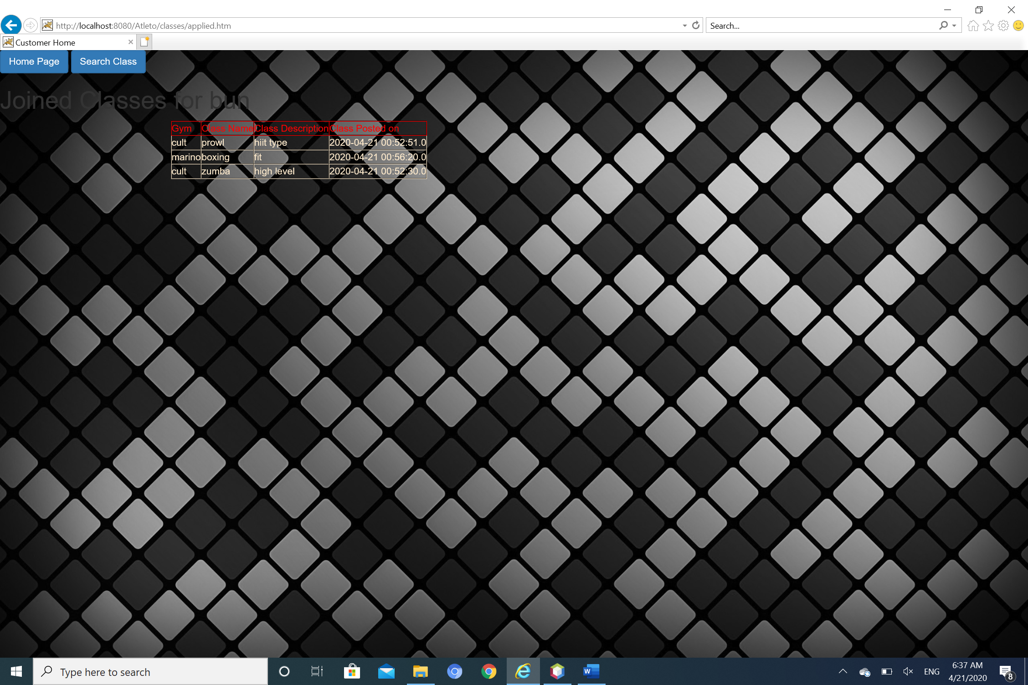

**Admin Login:**

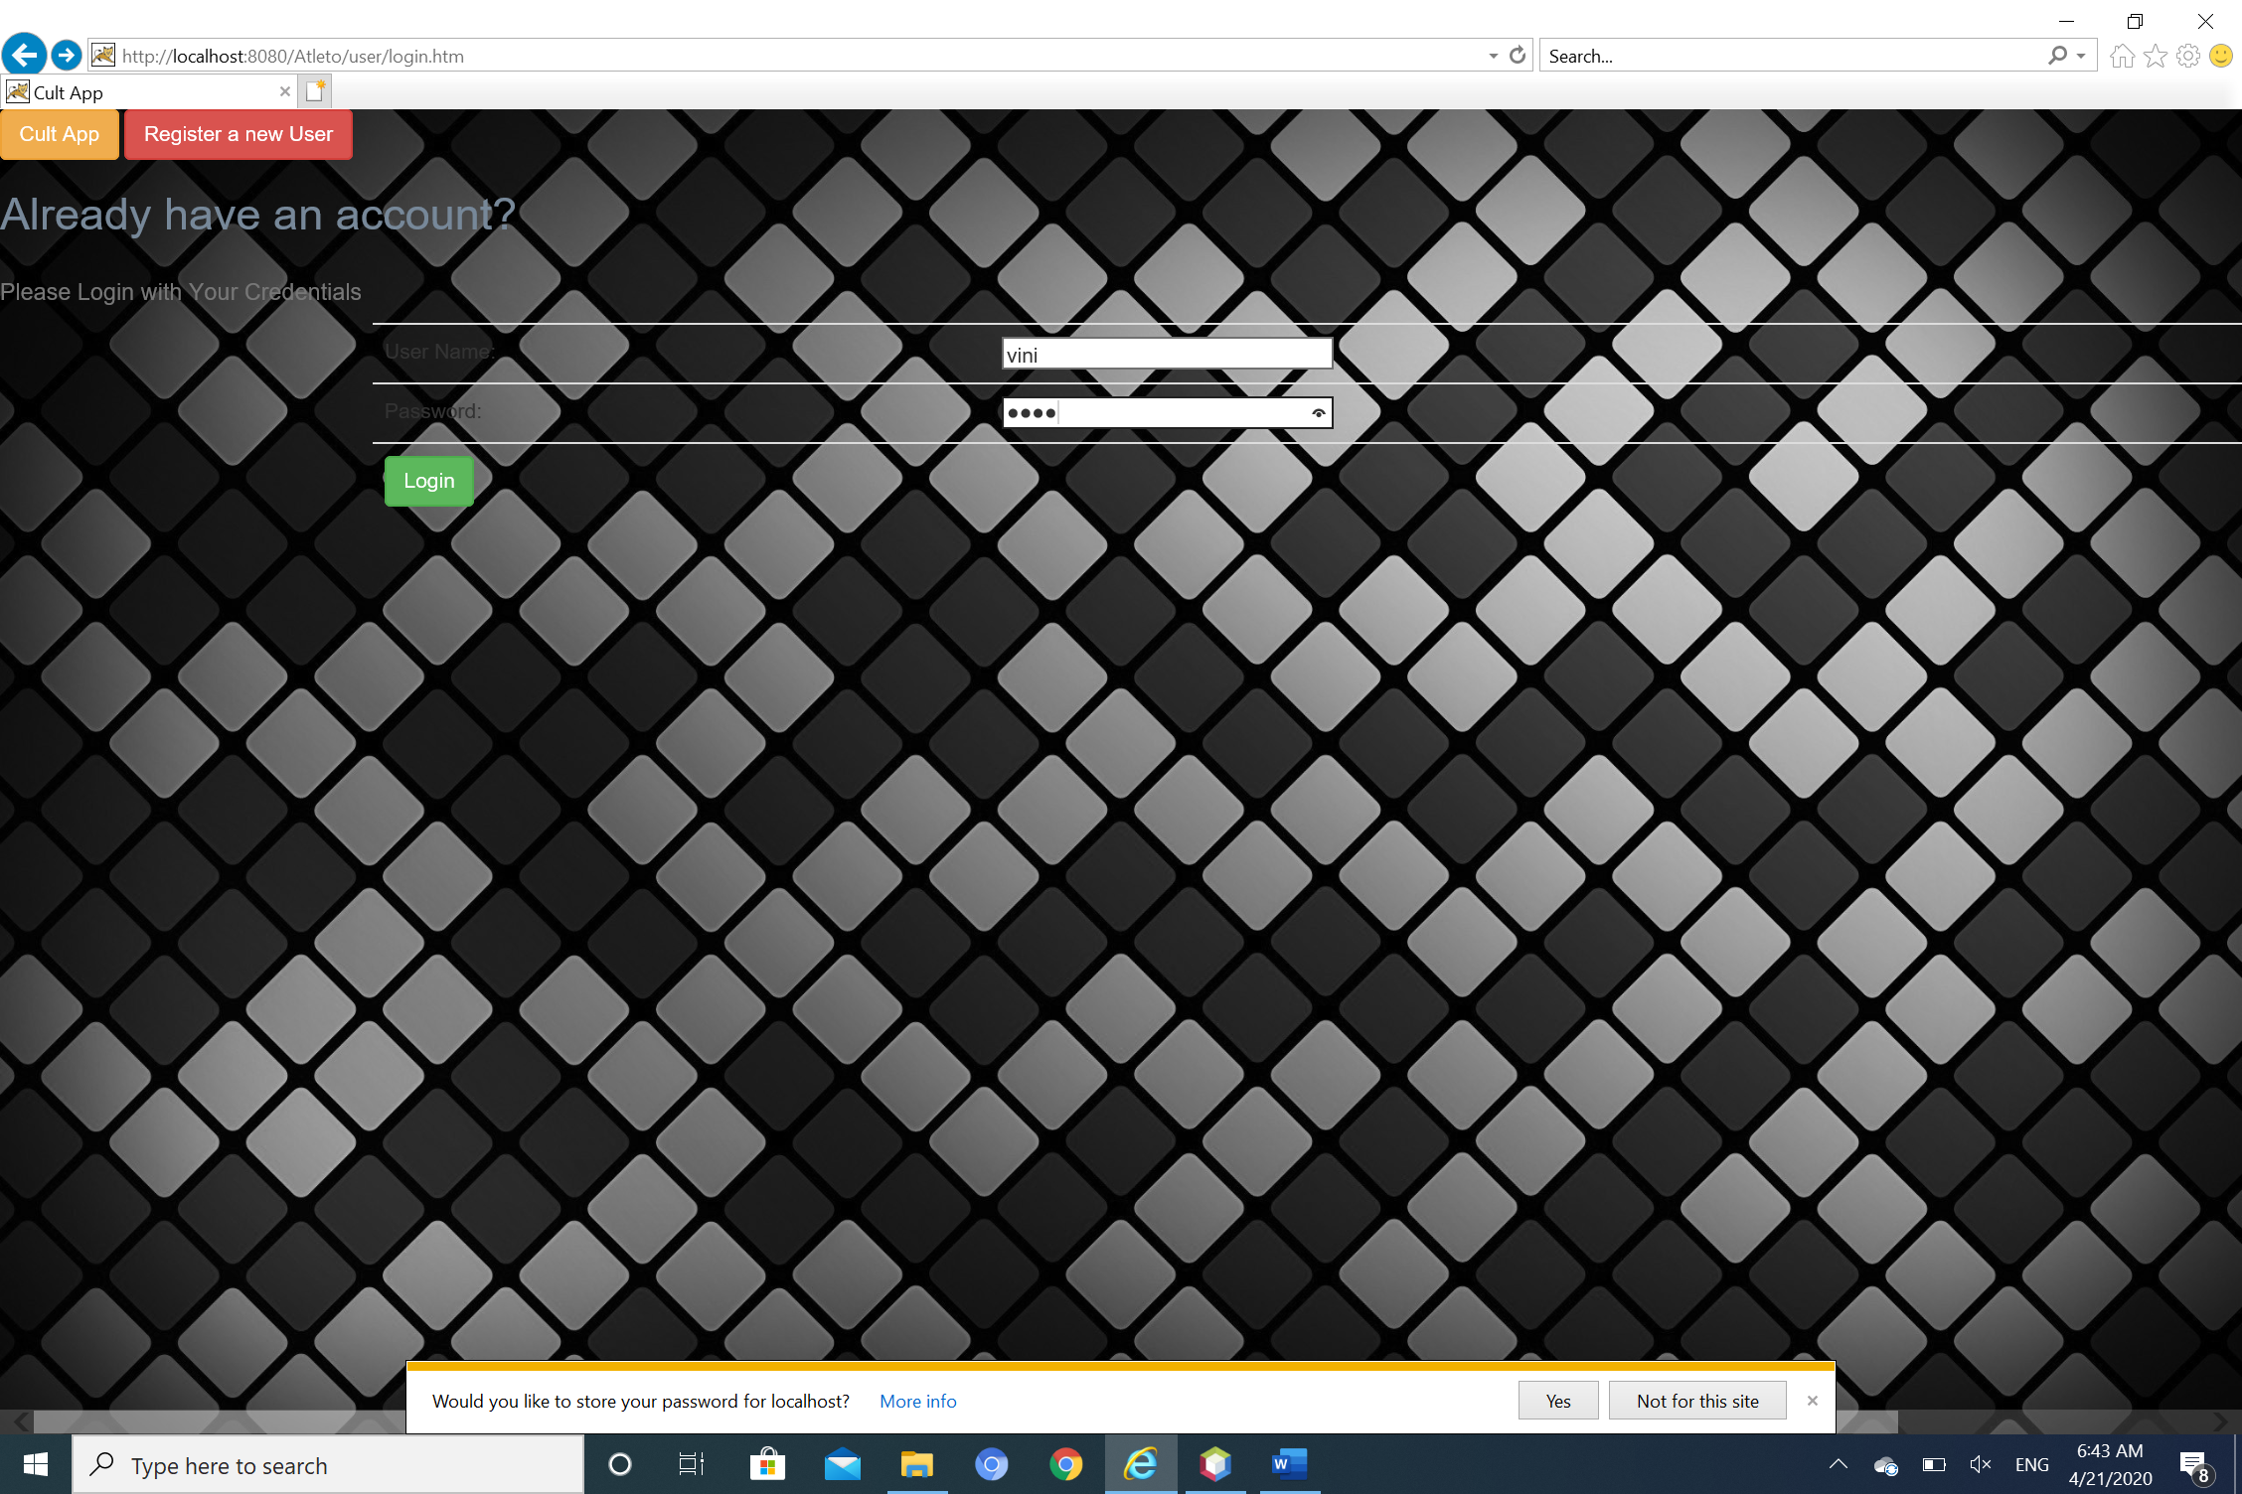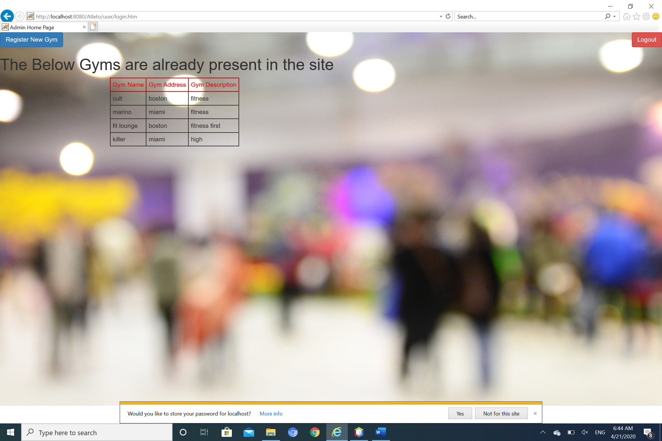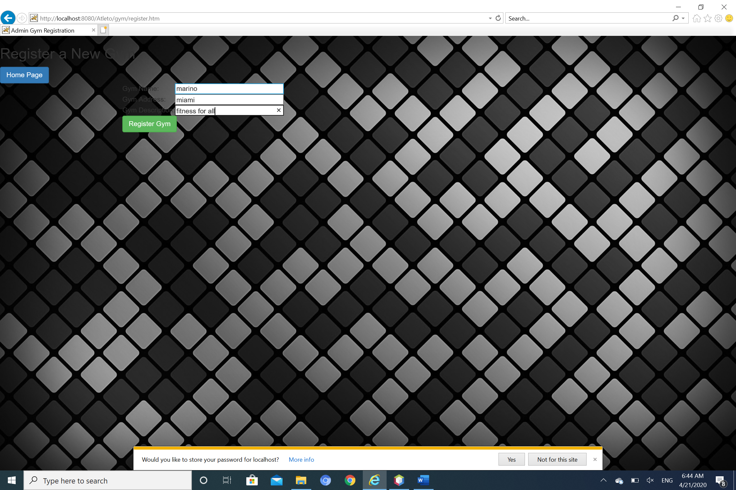

**Authorization Controller:**

**import javax.servlet.http.HttpServletRequest;**

**import javax.servlet.http.HttpSession;**

**import org.springframework.stereotype.Controller;**

**import org.springframework.web.bind.annotation.RequestMapping;**

**import org.springframework.web.bind.annotation.RequestMethod;**

**import org.springframework.web.servlet.ModelAndView;**

**import com.me.pojo.ClasList;**

**import com.me.pojo.User;**

**@Controller**

**@RequestMapping("/authorize/*")**

**public class Authorization1Controller {**

**@RequestMapping(value = "/authorize/error.htm", method = RequestMethod.GET)**

**protected ModelAndView addclass(HttpServletRequest request) throws Exception {**

**ModelAndView mv = new ModelAndView();**

**mv.setViewName("errorpage");**

**return mv;**

**}**

**@RequestMapping(value = "/authorize/ClasUpdateError.htm", method = RequestMethod.GET)**

**protected ModelAndView errorclass(HttpServletRequest request) throws Exception {**

**ModelAndView mv = new ModelAndView();**

**mv.setViewName("error-clasupdate");**

**return mv;**

**}**

**}**

**Classes Controller:**

**import java.util.Date;**

**import java.util.List;**

**import javax.servlet.http.HttpServletRequest;**

**import javax.servlet.http.HttpSession;**

**import org.hibernate.HibernateException;**

**import org.springframework.beans.factory.annotation.Autowired;**

**import org.springframework.beans.factory.annotation.Qualifier;**

**import org.springframework.http.HttpRequest;**

**import org.springframework.mail.SimpleMailMessage;**

**import org.springframework.mail.javamail.JavaMailSender;**

**import org.springframework.stereotype.Controller;**

**import org.springframework.validation.BindingResult;**

**import org.springframework.web.bind.WebDataBinder;**

**import org.springframework.web.bind.annotation.InitBinder;**

**import org.springframework.web.bind.annotation.ModelAttribute;**

**import org.springframework.web.bind.annotation.RequestMapping;**

**import org.springframework.web.bind.annotation.RequestMethod;**

**import org.springframework.web.servlet.ModelAndView;**

**import com.me.DAO.GymDAO;**

**import com.me.DAO.ClassesDAO;**

**import com.me.DAO.UserDAO;**

**import com.me.exception.ClassesException;**

**import com.me.pojo.Gym;**

**import com.me.pojo.ClasList;**

**import com.me.pojo.User;**

**import com.me.validator.ClassValidator;**

**@Controller**

**@RequestMapping("/classes/*")**

**public class ClassesController {**

**@Autowired**

**@Qualifier("classDao")**

**ClassesDAO classDao;**

**@Autowired**

**@Qualifier("userDao")**

**UserDAO userDao;**

**@Autowired**

**@Qualifier("gymDao")**

**GymDAO gymDao;**

**@Autowired**

**@Qualifier("classValidator")**

**ClassValidator validator;**

**@Autowired**

**private JavaMailSender mailSender;**

**@InitBinder**

**private void initBinder(WebDataBinder binder) {**

**binder.setValidator(validator);**

**}**

**@RequestMapping(value = "/classes/register.htm", method = RequestMethod.GET)**

**protected ModelAndView addclass(HttpServletRequest request) throws Exception {**

**ModelAndView mv = new ModelAndView();**

**HttpSession session = (HttpSession) request.getSession();**

**User u = (User) session.getAttribute("user");**

**mv.addObject("gymName", u.getGym().getGymName());**

**mv.addObject("claslist", new ClasList());**

**mv.setViewName("class-add");**

**return mv;**

**}**

**@RequestMapping(value = "/classes/register.htm", method = RequestMethod.POST)**

**protected ModelAndView registerNewUser(HttpServletRequest request, @ModelAttribute("claslist") ClasList claslist,**

**BindingResult result) throws Exception {**

**validator.validate(claslist, result);**

**if (result.hasErrors()) {**

**return new ModelAndView("class-add", "claslist", claslist);**

**}**

**try {**

**ModelAndView mv = new ModelAndView();**

**HttpSession session = (HttpSession) request.getSession();**

**User u = (User) session.getAttribute("user");**

**System.out.print("Add New Clas");**

**claslist.setGym(u.getGym());**

**claslist.setPostedName(u.getFirstName());**

**claslist.setPostedID(u.getUsername());**

**ClasList clas = classDao.register(claslist);**

**mv.addObject("classes", classDao.listGym(u.getGym()));**

**mv.addObject("claslist", clas);**

**mv.setViewName("host-home");**

**return mv;**

**} catch (ClassesException e) {**

**System.out.println("Exception: " + e.getMessage());**

**return new ModelAndView("error", "errorMessage", "error while adding clas");**

**}**

**}**

**@RequestMapping(value = "/classes/update.htm", method = RequestMethod.GET)**

**protected ModelAndView updateclass(HttpServletRequest request) throws Exception {**

**ModelAndView mv = new ModelAndView();**

**HttpSession session = (HttpSession) request.getSession();**

**int id = Integer.parseInt(request.getParameter("clasId"));**

**ClasList clas = classDao.getClas(id);**

**System.out.println("THE PRODUCT ID IS :" + id);**

**User u = (User) session.getAttribute("user");**

**mv.addObject("gymName", u.getGym().getGymName());**

**// mv.addObject("claslist", new ClasList());**

**mv.addObject("clasList", clas);**

**mv.setViewName("class-update");**

**return mv;**

**}**

**@RequestMapping(value = "/classes/update.htm", method = RequestMethod.POST)**

**protected ModelAndView updateclas(HttpServletRequest request) throws Exception {**

**ModelAndView mv = new ModelAndView();**

**HttpSession session = (HttpSession) request.getSession();**

**int id = Integer.parseInt(request.getParameter("clasId"));**

**ClasList clas = classDao.getClas(id);**

**clas.setClasName(request.getParameter("clasName"));**

**clas.setClasDesc(request.getParameter("clasDesc"));**

**System.out.println("THE PRODUCT ID IS :" + id);**

**classDao.update(clas);**

**User u = (User) session.getAttribute("user");**

**mv.addObject("clasList", clas);**

**mv.setViewName("update-success");**

**return mv;**

**}**

**@RequestMapping(value = "/classes/modify.htm", method = RequestMethod.GET)**

**protected ModelAndView modifyclass(HttpServletRequest request) throws Exception {**

**ModelAndView mv = new ModelAndView();**

**HttpSession session = (HttpSession) request.getSession();**

**int id = Integer.parseInt(request.getParameter("clasId"));**

**ClasList clas = classDao.getClas(id);**

**System.out.println("THE PRODUCT ID IS :" + id);**

**User u = (User) session.getAttribute("user");**

**mv.addObject("gymName", u.getGym().getGymName());**

**// mv.addObject("claslist", new ClasList());**

**mv.addObject("clasList", clas);**

**mv.setViewName("j-delete");**

**return mv;**

**}**

**@RequestMapping(value = "/classes/modify.htm", method = RequestMethod.POST)**

**protected ModelAndView modifyClas(HttpServletRequest request, @ModelAttribute("claslist") ClasList claslist,**

**BindingResult result) throws Exception {**

**// validator.validate(claslist, result);**

**// if (result.hasErrors()) {**

**// return new ModelAndView("class-add", "claslist", claslist);**

**// }**

**try {**

**ModelAndView mv = new ModelAndView();**

**HttpSession session = (HttpSession) request.getSession();**

**int id = Integer.parseInt(request.getParameter("clasId"));**

**ClasList clas = classDao.getClas(id);**

**System.out.println("THE PRODUCT ID IS :" + id);**

**classDao.deleteClas(clas);**

**User u = (User) session.getAttribute("user");**

**mv.addObject("clasList", clas);**

**mv.setViewName("delete-success");**

**return mv;**

**} catch (ClassesException e) {**

**System.out.println("Exception: " + e.getMessage());**

**return new ModelAndView("error", "errorMessage", "error while adding clas");**

**}**

**}**

**@RequestMapping(value = "/classes/add.htm", method = RequestMethod.POST)**

**protected ModelAndView addClas(HttpServletRequest request) throws Exception {**

**try {**

**boolean flag = false;**

**ModelAndView mv = new ModelAndView();**

**HttpSession session = (HttpSession) request.getSession();**

**User u = (User) session.getAttribute("user");**

**int clas_id = Integer.parseInt(request.getParameter("clasID"));**

**for (ClasList clas1 : u.getClaslists()) {**

**if (clas1.getClasID() == clas_id) {**

**flag = true;**

**}**

**}**

**System.out.print("Add New Clas");**

**if (!flag) {**

**ClasList clas = classDao.getClas(clas_id);**

**// u.getClaslists().add(clas);**

**userDao.update(u, clas);**

**System.out.println("Entered the clas addition new para");**

**clas.getUsers().add(u);**

**classDao.update(clas);**

**String address = u.getEmail().getEmailAddress();**

**String subject = "Clas Applied Notification for " +clas.getClasName();**

**String message = "Dear "+u.getFirstName()+","+"\n"+"\nYou Applied for the position : "+clas.getClasName()+"\n"+"\nClas Desc : " +clas.getClasDesc()**

**+"\non : " +new Date() +"\n"+"\n"+"\nThank you for using our online Clas Portal"+"\n"+"\nRegards"+"\nAdmin";**

**SimpleMailMessage email = new SimpleMailMessage();**

**email.setTo(address);**

**email.setSubject(subject);**

**email.setText(message);**

**mailSender.send(email);**

**mv.addObject("classes", classDao.listGym(u.getGym()));**

**mv.addObject("claslist", clas);**

**mv.setViewName("add-success");**

**flag = false;**

**return mv;**

**} else {**

**System.out.println("Entered the other para where its already added");**

**mv.addObject("classes", null);**

**mv.setViewName("add-already");**

**return mv;**

**}**

**} catch (ClassesException e) {**

**System.out.println("Exception: " + e.getMessage());**

**return new ModelAndView("error", "errorMessage", "error while adding clas");**

**}**

**}**

**@RequestMapping(value = "/classes/search.htm", method = RequestMethod.GET)**

**protected ModelAndView searchclas(HttpServletRequest request) throws Exception {**

**ModelAndView mv = new ModelAndView();**

**HttpSession session = (HttpSession) request.getSession();**

**User u = (User) session.getAttribute("user");**

**mv.setViewName("search-class");**

**return mv;**

**}**

**@RequestMapping(value = "/classes/search.htm", method = RequestMethod.POST)**

**protected ModelAndView searchclass(HttpServletRequest request) throws Exception {**

**ModelAndView mv = new ModelAndView();**

**HttpSession session = (HttpSession) request.getSession();**

**User u = (User) session.getAttribute("user");**

**String name = request.getParameter("inputtext");**

**String search = request.getParameter("searchkey");**

**if (search.equalsIgnoreCase("clasname")) {**

**List<ClasList> classes = classDao.listClasname(name);**

**mv.addObject("classes", classes);**

**if (classes.isEmpty())**

**System.out.println("The returned list is empty");**

**for (ClasList clas : classes) {**

**System.out.println("The matching classes are : " + clas.getClasName());**

**}**

**} else if (search.equalsIgnoreCase("gym")) {**

**Gym c = gymDao.get(name);**

**if (c == null) {**

**mv.setViewName("search-fail");**

**return mv;**

**}**

**List<ClasList> classes = classDao.listGym(c);**

**if (classes.isEmpty()) {**

**mv.setViewName("search-failclasses");**

**return mv;**

**}**

**mv.addObject("classes", classes);**

**}**

**mv.setViewName("search-success");**

**return mv;**

**}**

**@RequestMapping(value = "/classes/applied.htm", method = RequestMethod.GET)**

**protected ModelAndView appliedclas(HttpServletRequest request) throws Exception {**

**ModelAndView mv = new ModelAndView();**

**mv.setViewName("classes-joined");**

**return mv;**

**}**

**@RequestMapping(value = "/classes/viewallclasses.htm", method = RequestMethod.GET)**

**protected ModelAndView viewAllClas(HttpServletRequest request) throws Exception {**

**ModelAndView mv = new ModelAndView();**

**mv.addObject("classes", classDao.list());**

**mv.setViewName("viewallclasses");**

**return mv;**

**}**

**}**

**Gym Controller:**

**import java.util.List;**

**import javax.servlet.http.HttpServletRequest;**

**import javax.servlet.http.HttpSession;**

**import org.springframework.beans.factory.annotation.Autowired;**

**import org.springframework.beans.factory.annotation.Qualifier;**

**import org.springframework.stereotype.Controller;**

**import org.springframework.validation.BindingResult;**

**import org.springframework.web.bind.WebDataBinder;**

**import org.springframework.web.bind.annotation.InitBinder;**

**import org.springframework.web.bind.annotation.ModelAttribute;**

**import org.springframework.web.bind.annotation.RequestMapping;**

**import org.springframework.web.bind.annotation.RequestMethod;**

**import org.springframework.web.servlet.ModelAndView;**

**import com.me.DAO.GymDAO;**

**import com.me.DAO.ClassesDAO;**

**import com.me.DAO.UserDAO;**

**import com.me.exception.GymException;**

**import com.me.pojo.Gym;**

**import com.me.pojo.ClasList;**

**import com.me.pojo.User;**

**import com.me.validator.GymValidator;**

**@Controller**

**@RequestMapping("/gym/*")**

**public class GymController {**

**@Autowired**

**@Qualifier("gymDao")**

**GymDAO gymDao;**

**@Autowired**

**@Qualifier("gymValidator")**

**GymValidator validator;**

**@Autowired**

**@Qualifier("classDao")**

**ClassesDAO classDao;**

**@Autowired**

**@Qualifier("userDao")**

**UserDAO userDao;**

**@InitBinder**

**private void initBinder(WebDataBinder binder) {**

**binder.setValidator(validator);**

**}**

**@RequestMapping(value = "/gym/register.htm", method = RequestMethod.POST)**

**protected ModelAndView registerNewUser(HttpServletRequest request, @ModelAttribute("gym") Gym gym, BindingResult result) throws Exception {**

**validator.validate(gym, result);**

**if (result.hasErrors()) {**

**return new ModelAndView("register-gym", "gym", gym);**

**}**

**try {**

**System.out.print("registerNewGym");**

**Gym c = gymDao.register(gym);**

**return new ModelAndView("gym-add", "gym", c);**

**} catch (GymException e) {**

**System.out.println("Exception: " + e.getMessage());**

**return new ModelAndView("error", "errorMessage", "error while registering gym");**

**}**

**}**

**@RequestMapping(value = "/gym/register.htm", method = RequestMethod.GET)**

**protected ModelAndView registerUser() throws Exception {**

**System.out.print("registerUser");**

**return new ModelAndView("register-gym", "gym", new Gym());**

**}**

**@RequestMapping(value = "/gym/delete.htm", method = RequestMethod.POST)**

**protected ModelAndView searchclass(HttpServletRequest request) throws Exception {**

**ModelAndView mv = new ModelAndView();**

**HttpSession session = (HttpSession) request.getSession();**

**User u = (User) session.getAttribute("user");**

**int compId = Integer.parseInt(request.getParameter("compID"));**

**Gym comp = gymDao.getById(compId);**

**gymDao.delete(comp);**

**mv.addObject("gyms", gymDao.list());**

**mv.setViewName("admin-home");**

**return mv;**

**}**

**}**

**Home Controller:**

**import java.text.DateFormat;**

**import java.util.Date;**

**import java.util.Locale;**

**import org.slf4j.Logger;**

**import org.slf4j.LoggerFactory;**

**import org.springframework.beans.factory.annotation.Autowired;**

**import org.springframework.beans.factory.annotation.Qualifier;**

**import org.springframework.stereotype.Controller;**

**import org.springframework.ui.Model;**

**import org.springframework.web.bind.annotation.RequestMapping;**

**import org.springframework.web.bind.annotation.RequestMethod;**

**import com.me.DAO.HostDAO;**

**/\*\***

**\* Handles requests for the application home page.**

**\*/**

**@Controller**

**public class HomeController {**

**private static final Logger logger = LoggerFactory.getLogger(HomeController.class);**

**/\*\***

**\* Simply selects the home view to render by returning its name.**

**\*/**

**@RequestMapping(value = "/home.htm", method = RequestMethod.GET)**

**public String home(Locale locale, Model model) {**

**logger.info("Welcome home! The client locale is {}.", locale);**

**Date date = new Date();**

**DateFormat dateFormat = DateFormat.getDateTimeInstance(DateFormat.LONG, DateFormat.LONG, locale);**

**String formattedDate = dateFormat.format(date);**

**model.addAttribute("serverTime", formattedDate );**

**return "index";**

**}**

**@RequestMapping(value = "/", method = RequestMethod.GET)**

**public String home1(Locale locale, Model model) {**

**logger.info("Welcome home! The client locale is {}.", locale);**

**Date date = new Date();**

**DateFormat dateFormat = DateFormat.getDateTimeInstance(DateFormat.LONG, DateFormat.LONG, locale);**

**String formattedDate = dateFormat.format(date);**

**model.addAttribute("serverTime", formattedDate );**

**return "index";**

**}**

**}**

**UserController:**

**import java.util.Set;**

**import javax.servlet.http.HttpServletRequest;**

**import javax.servlet.http.HttpSession;**

**import org.springframework.beans.factory.annotation.Autowired;**

**import org.springframework.beans.factory.annotation.Qualifier;**

**import org.springframework.stereotype.Controller;**

**import org.springframework.validation.BindingResult;**

**import org.springframework.web.bind.WebDataBinder;**

**import org.springframework.web.bind.annotation.InitBinder;**

**import org.springframework.web.bind.annotation.ModelAttribute;**

**import org.springframework.web.bind.annotation.RequestMapping;**

**import org.springframework.web.bind.annotation.RequestMethod;**

**import org.springframework.web.servlet.ModelAndView;**

**import com.me.DAO.GymDAO;**

**import com.me.DAO.ClassesDAO;**

**import com.me.DAO.UserDAO;**

**import com.me.exception.UserException;**

**import com.me.pojo.Gym;**

**import com.me.pojo.ClasList;**

**import com.me.pojo.User;**

**import com.me.validator.UserValidator;**

**@Controller**

**@RequestMapping("/user/*")**

**public class UserController {**

**@Autowired**

**@Qualifier("userDao")**

**UserDAO userDao;**

**@Autowired**

**@Qualifier("userValidator")**

**UserValidator validator;**

**@Autowired**

**@Qualifier("gymDao")**

**GymDAO gymDao;**

**@Autowired**

**@Qualifier("classDao")**

**ClassesDAO classDao;**

**@InitBinder**

**private void initBinder(WebDataBinder binder) {**

**binder.setValidator(validator);**

**}**

**@RequestMapping(value = "/user/login.htm", method = RequestMethod.GET)**

**protected String goToUserHome(HttpServletRequest request) throws Exception {**

**return "home";**

**}**

**@RequestMapping(value = "/user/login.htm", method = RequestMethod.POST)**

**protected ModelAndView loginUser(HttpServletRequest request) throws Exception {**

**ModelAndView mv = new ModelAndView();**

**HttpSession session = (HttpSession) request.getSession();**

**try {**

**System.out.print("loginUser");**

**User u = userDao.get(request.getParameter("username"), request.getParameter("password"));**

**if(u == null){**

**System.out.println("UserName/Password does not exist");**

**session.setAttribute("errorMessage", "UserName/Password does not exist");**

**mv.setViewName("error");**

**return mv;**

**}**

**session.setAttribute("user", u);**

**String role = u.getRole().trim();**

**if (role.equals("customer")){**

**System.out.println("Entered here");**

**mv.addObject("classes", classDao.list());**

**mv.setViewName("customer-home");**

**return mv ;**

**}**

**else if (role.equals("host")){**

**mv.addObject("classes", classDao.listGym(u.getGym()));**

**mv.setViewName("host-home");**

**return mv;**

**}**

**else if(role.equals("admin")){**

**// System.out.println("The email addrees of Admin : " +u.getFirstName()+" is "+u.getEmail().getEmailAddress());**

**mv.addObject("gyms", gymDao.list());**

**mv.setViewName("admin-home");**

**return mv;**

**}**

**else**

**return null;**

**} catch (UserException e) {**

**System.out.println("Exception: " + e.getMessage());**

**session.setAttribute("errorMessage", "error while login");**

**mv.setViewName("error");**

**return mv;**

**}**

**}**

**@RequestMapping(value = "/user/register.htm", method = RequestMethod.GET)**

**protected ModelAndView registerUser() throws Exception {**

**System.out.print("registerUser");**

**ModelAndView mv = new ModelAndView();**

**mv.addObject("gyms", gymDao.list());**

**mv.addObject("user",new User());**

**mv.setViewName("register-user");**

**// return new ModelAndView("register-user", "user", new User());**

**return mv;**

**}**

**@RequestMapping(value = "/user/customer.htm", method = RequestMethod.GET)**

**protected ModelAndView customerHome() throws Exception {**

**System.out.print("Customer Home");**

**ModelAndView mv = new ModelAndView();**

**mv.addObject("classes", classDao.list());**

**mv.setViewName("customer-home");**

**// return new ModelAndView("register-user", "user", new User());**

**return mv;**

**}**

**@RequestMapping(value = "/user/host.htm", method = RequestMethod.GET)**

**protected ModelAndView hostHome(HttpServletRequest request) throws Exception {**

**System.out.print("Host Home");**

**HttpSession session = (HttpSession) request.getSession();**

**User u = (User) session.getAttribute("user");**

**ModelAndView mv = new ModelAndView();**

**mv.addObject("classes", classDao.listGym(u.getGym()));**

**mv.setViewName("host-home");**

**return mv;**

**// return new ModelAndView("register-user", "user", new User());**

**}**

**@RequestMapping(value = "/user/admin.htm", method = RequestMethod.GET)**

**protected ModelAndView adminHome() throws Exception {**

**System.out.print("Admin Home");**

**ModelAndView mv = new ModelAndView();**

**mv.addObject("gyms", gymDao.list());**

**mv.setViewName("admin-home");**

**// return new ModelAndView("register-user", "user", new User());**

**return mv;**

**}**

**@RequestMapping(value = "/user/register.htm", method = RequestMethod.POST)**

**protected ModelAndView registerNewUser(HttpServletRequest request, @ModelAttribute("user") User user, BindingResult result) throws Exception {**

**validator.validate(user, result);**

**if (result.hasErrors()) {**

**// return new ModelAndView("register-user", "user", user);**

**ModelAndView mv = new ModelAndView();**

**mv.addObject("gyms", gymDao.list());**

**mv.addObject("user", user);**

**mv.setViewName("register-user");**

**return mv;**

**}**

**try {**

**System.out.print("registerNewUser");**

**String role = request.getParameter("myRole");**

**user.setRole(role);**

**String gym = request.getParameter("myGym");**

**System.out.println("The Gym is :" +gym);**

**Gym c = gymDao.get(gym);**

**System.out.println("The gym ID : " +c.getGymId());**

**user.setGym(c);**

**User u = userDao.register(user);**

**request.getSession().setAttribute("user", u);**

**return new ModelAndView("user-home", "user", u);**

**} catch (UserException e) {**

**System.out.println("Exception: " + e.getMessage());**

**return new ModelAndView("error", "errorMessage", "error while login");**

**}**

**}**

**}**